Darshana pubudu keerthirathna

ICM 106 OR23106564

**DBMS IN-CLASS ASSIGNMENT 03**

CREATE DATABASE gamekade;

USE gamekade;

CREATE TABLE customer(

customerId VARCHAR(6) PRIMARY KEY,

name VARCHAR(30) NOT NULL,

address VARCHAR(30),

salary DECIMAL(10,2)

);

DESC Customer;

CREATE TABLE orders(

orderId VARCHAR(6) PRIMARY KEY,

orderDate DATE,

customerId VARCHAR(6),

CONSTRAINT FOREIGN KEY(customerId) REFERENCES customer(customerId)

);

DESC orders;

CREATE TABLE item(

itemCode VARCHAR(6) PRIMARY KEY,

description VARCHAR(30) NOT NULL,

unitPrice DECIMAL(10,2),

qtyOnHand INT(10)

);

DESC item;

CREATE TABLE orderDetails(

orderId VARCHAR(6),

itemCode VARCHAR(6),

quantity INT(10),

CONSTRAINT FOREIGN KEY(orderId) REFERENCES orders(orderId),

CONSTRAINT FOREIGN KEY(itemCode) REFERENCES item(itemCode),

CONSTRAINT COMPOSITE PRIMARY KEY(orderId,itemCode)

);

DESC orderDetails;

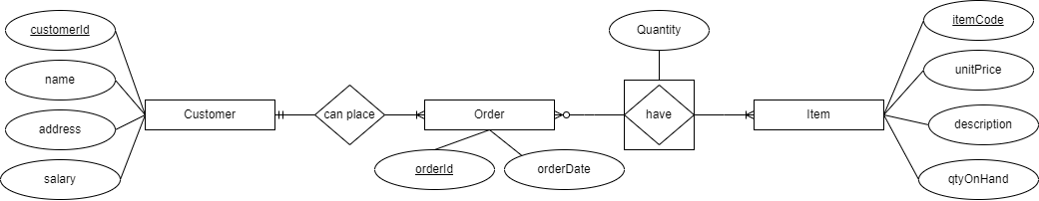

INSERT INTO customer VALUES('c001','Josapin','Pol Waththa',85000.00);

INSERT INTO customer VALUES('c002','Magilin','Kanattha Para',65000.00);

INSERT INTO customer VALUES('c003','Siripala','7 Kanuwa',95000.00);

INSERT INTO orders VALUES('o001','2023-10-13','c002');

INSERT INTO orders VALUES('o002','2023-10-14','c003');

INSERT INTO orders VALUES('o003','2023-10-14','c001');

INSERT INTO orders VALUES('O004','2023-10-15','c002');

INSERT INTO orders VALUES('O005','2023-10-16','c003');

INSERT INTO item VALUES('i001','Dhal',200.00,50);

INSERT INTO item VALUES('i002','Suger',190.00,100);

INSERT INTO item VALUES('i003','Rice',210.00,150);

INSERT INTO item VALUES('i004','Chocolate Biscuits',95.00,45);

INSERT INTO item VALUES('i005','Onion',160.00,35);

INSERT INTO orderDetails VALUES('o001','i001',1);

INSERT INTO orderDetails VALUES('o001','i003',5);

INSERT INTO orderDetails VALUES('o001','i005',1);

INSERT INTO orderDetails VALUES('o002','i002',2);

INSERT INTO orderDetails VALUES('o002','i003',10);

INSERT INTO orderDetails VALUES('o002','i004',1);

INSERT INTO orderDetails VALUES('o003','i003',5);

INSERT INTO orderDetails VALUES('o003','i002',2);

INSERT INTO orderDetails VALUES('o003','i004',2);